**sssANTI-CHEATING PLUG-IN FOR E-RTU**

**A Capstone Project & Research 1**

**Presented to the Faculty of the Engineering, Architecture and Technology**

**RIZAL TECHNOLOGICAL UNIVERSITY**

Bgry. Malamig, Boni Avenue

Mandaluyong City

In Partial Fulfillment of the Requirements for the Degree of

Bachelor of Science in Information Technology

**Department of Information Technology**

by

**Arandia, Al Vince R.**

**Dela Torre, Pamela Rose P.**

**Delposo, Renzi B.**

**Diestro, Clisheyl Ruth C.**

**Santos, Angelica A.**

December 2023

**APPROVAL SHEET**

This Capstone Project 1 entitled, **“*ANTI CHEATING PLUG-IN FOR E-RTU”*,** prepared and submitted by AL VINCE R. ARANDIA, PAMELA ROSE P. DELA TORRE, in partial fulfillment of the course requirements for the degree of BACHELOR OF SCIECNE IN INFORMATION TECHNOLOGY, has been examined and recommended for acceptance and approval for Oral Examination.

**Engr. Greta Rosario**

Adviser

Approved by the Committee of Oral Examination on November 18, 2023 with a grade of ____.

**Dr. Lea Nisperos**

Chairman

**Mr. Joseph Carpio Dr. Reynaldo Alvez**

Member Member

Accepted as partial fulfillment of the course requirements for the degree in Bachelor of Science in Information Technology.

**ENGR. LORENZO C. CARANGUIAN**

Dean, College of Engineering and Architecture

Date: ________

**TABLE OF CONTENTS**

# Title Page i

Approval Sheet ii

Dedication iii

Table of Contents iv

List of Tables vii

List of Figures viii

Abstract x

**Chapter I. THE PROBLEM AND ITS BACKGROUND**

1. Introduction 1
2. Background of the Study 2
3. Purpose and Description of the Project 4
4. Significance of the Study 5
5. Statement of the Problem 7
6. Scope and Limitation 8
7. Conceptual Framework 9
8. Operational Definition of Terms 10

**Chapter II. REVIEW OF RELATED LITERATURES AND STUDIES**

Literature 12

Traditional Proctoring 12

Online Education during the COVID-19 Pandemic 14

Online Proctoring 17

Development of Online Examination Platforms 19

Online Cheating 21

Use of AI in Cheating During Online Examination 23

Development of Plug-ins 25

Tool Development for Anti-Cheating during Examinations 27

Online Proctoring vs. Traditional Proctoring 30

**Chapter III. TECHNICAL BACKGROUND**

1. Technical Background 31
2. Technicality of the Project 31
3. Technology Used 47
4. How the Project Works 51
5. REFERENCES 53

**Chapter IV. METHODOLOGY**

Environment 12

Requirements Specifications 14

Online Proctoring 17

Development of Online Examination Platforms 19

Online Cheating 21

Use of AI in Cheating During Online Examination 23

Development of Plug-ins 25

Tool Development for Anti-Cheating during Examinations 27

Online Proctoring vs. Traditional Proctoring 30

**Chapter V.**

**LIST OF FIGURES**

Diagram 1 31

Diagram 2 31

Diagram 3 33

Diagram 4 34

Figure 1 35

Figure 2 36

Figure 3 37

Figure 4 38

Figure 5 39

Figure 6 40

Figure 7 41

Figure 8 42

Figure 9 43

Figure 10 44

Figure 11 45

Figure 12 46

**CHAPTER 1**

**INTRODUCTION**

With the rapid advancements of technology over the last few years, many have offered online courses due to their convenience. Adopting e-learning tools by schools, teachers, and students enables teachers to provide teaching interactively, easily exchange resources, and enhance collaboration and engagement among students (Elaish et al., 2019). However, even with the growth opportunity and expansion of modalities, a few issues were raised, questioning how to maintain the integrity of every course assessment.

In the dynamic realm of online education, Learning Management Systems (LMS) play a pivotal role in shaping the future of teaching and learning. Moodle, short for Modular Object-Oriented Dynamic Learning Environment, stands out as a robust and widely adopted open-source LMS that facilitates the creation and management of online courses. Originally developed by Martin Dougiamas in 2002, Moodle has evolved into a versatile platform, offering educators and institutions the tools needed to deliver engaging and effective e-learning experiences.

Moodle's strength lies in its adaptability and extensibility through plugins—additional pieces of software that enhance and extend the platform's functionality. These plugins are crucial in addressing specific needs and challenges faced by educational institutions. They cover a broad spectrum of features, ranging from administrative tools to collaborative activities, enriching educators' and students' overall learning experience. Rizal Technological University (RTU) has taken a proactive approach to leveraging the power of Moodle by introducing its Learning Management System, e-RTU. This platform is a testament to RTU's commitment to providing a dynamic and inclusive education tailored for online distance learning, transcending geographical limitations.

The proponents have undertaken a research initiative to develop an Anti-Cheating Plug–in with Artificial Intelligence (AI) to maintain academic integrity. This innovative approach addresses the challenges associated with online assessments, ensuring a thorough and accurate evaluation of students. The Anti-Cheating Plug-in authenticates students, prevents academic misconduct, and ensures constant supervision during examinations. The incorporation of AI enables the plugin to detect if any attempt of cheating is identified, thereby promoting fairness and honesty in assessment—an essential consideration as educational institutions navigate the complexities of online examinations. This project represents a significant step towards bridging the gap between traditional learning and the evolving landscape of digital education.

**BACKGROUND OF THE STUDY**

During the emergence of Covid-19, academic dishonesty was given more highlight. This has had a huge impact, particularly in the education sector, resulting in universities being forced to shift to online modality due to implemented lockdowns. Every constituent of education has undergone rapid and sudden adjustment to distance learning, even with a lack of preparation to ensure the continuity of learning. However, many universities lacking experience with online modality have found this urgent move challenging (Rapanta et al., 2020).

The Covid-19 pandemic has led to the adoption of e-learning as a viable option for education. The majority of educational institutions are exploring and adopting e-learning as a means to facilitate student engagement in the new normal. Furthermore, educators are looking into various e-teaching software options to provide their students with the utmost convenience. (Khan et al., 2021). The utilization of E-learning platforms has allowed students to communicate and engage in learning activities through technological devices from their homes. Additionally, it enables learning providers to effectively manage, strategize, implement, and monitor the learning and teaching process.

Although modern online learning platforms and technology enabled the continuation of everyday teaching and learning activities amidst the pandemic, pedagogical concerns arise. As classes were moved online, academic institutions faced increasing challenges in ensuring the integrity of assessments. According to Martin et al. (2020), the assessment of courses poses significant challenges in online learning, mostly stemming from the inherent absence of direct control over both students and educators. As exams were also taken online, this presented challenges for educators in ensuring their students' academic integrity. Assessment practices were compromised during the early pandemic as everyone was too pressured with the shift (Lee, Fanguy, Bligh, et al., 2021).

The issue of academic dishonesty, which was already a considerable concern before the pandemic, has been further aggravated by continuous technological advancements. In Noorbebahani's (2022) research, different types of online cheating were identified. These include employing diverse strategies to obtain unauthorized materials, such as notes and textbooks, utilizing additional devices to access online resources, engaging in collaborative efforts with others, and even resorting to outsourcing the examination to someone else.

In response to growing concerns, various tools have emerged to monitor online exams such as proctoring systems. This technological solution serves the purpose of verifying the identity of students and identifying any potentially suspicious activity that may occur during the examination, aiming to deter academic dishonesty (Kharbat et al., 2021).

Plugins or add-ons were also developed and integrated into numerous systems to prevent academic irregularities and ensure integrity during exams. These plugins mainly function as proctors that monitor students during exams, some of which are assisted by artificial intelligence. Additionally, AI-based proctoring emerges as a comprehensive tool that keeps a vigilant eye on students and detects any attempts at cheating during online exams, according to (Motwani et al., 2021). Like a human proctor, these plugins evaluate students' actions, surroundings, and movements as they tackle their exams.

**PURPOSE AND DESCRIPTION OF THE PROJECT**

The project Anti–Cheating Plugin is dedicated to enhancing the integrity and equity of the assessment process in a digital educational environment through the integration of an AI-driven anti-cheating plugin to the existing LMS of Rizal Technological University known as e-RTU. This innovative project harnesses artificial intelligence to proactively identify and mitigate instances of academic dishonesty during quizzes and exams. Doing so ensures that every student is evaluated solely on their own knowledge and abilities, free from any unfair advantages or unethical practices. Through the Anti–Cheating Plugin project, the proponents are dedicated to upholding academic integrity, transparency, and educational excellence. Additionally, they aspire to create an environment where students can showcase their true potential, and educators can make data-informed decisions to enhance the learning experience.

**SIGNIFICANCE OF THE STUDY**

The Anti–Cheating Plugin is a security enhancement utilizing artificial intelligence (AI) to effectively identify and detect cheating instances during online exams. These cutting-edge technologies significantly improve the overall integrity of the e-learning environment, ensuring a fair and secure assessment process for both instructors and students. By incorporating this plugin, the e-rtu LMS takes a substantial leap forward in fostering a more efficient and streamlined approach to tackling issues related to academic dishonesty paving the way for a more secure and trustworthy online educational experience. The present study holds the capacity to have a beneficial influence on instructors, students, universities, and future researchers.

**To the Professors**

The Anti–Cheating Plugin can help reduce the time and effort they spend detecting and preventing cheating. It can also help them assess their students fairly and accurately. Additionally, the plugin can help to improve the academic integrity of their institution.

**To the Students**

Anti–Cheating Plugin can help them focus on their studies and demonstrate their knowledge and skills. It can also help them to avoid the negative consequences of cheating, such as disciplinary action or academic failure. Additionally, the plugin can help to create a more level playing field for all students.

**To the Institution**

Anti–Cheating Plugin can help protect their academic reputation and ensure their graduates are well-prepared for the workforce. It can also help them to reduce the costs associated with cheating, such as the cost of re-exams and the cost of investigating and prosecuting cheaters. Additionally, Anti–Cheating Plugin can help universities to improve the quality of their educational experience.

**To the Researchers**

Anti–Cheating Plugin is a new and innovative system that has the potential to revolutionize the way that online exams are conducted. Future researchers can build on the work done by the developers of Anti–Cheating Plugin to improve the system further and develop new anti-cheating technologies.

**STATEMENT OF THE PROBLEM**

With the increasing concerns regarding academic dishonesty during examinations, an AI integrated proctoring plugin will be developed as a tool to lessen the risk of cheating and to continuously supervise students during examination process.

Throughout the study the proponents aim to address the following questions:

1. What are the benefits of using AI-powered anti-cheating plugins in e-RTU?
2. How effective is the proposed Anti–Cheating Plugin in detecting various forms of academic dishonesty, unauthorized collaboration, and exam cheating?
3. Why should AI be integrated into Anti–Cheating Plugin?

**SCOPE AND LIMITATIONS**

**SCOPE**

The anti-cheating plugin is intended to be used exclusively in E-RTU, serving only as a proctoring tool for teachers.

**Admin Module**

The anti-cheating plugin is to be installed by the admin of e-RTU. Only after the installation will the anti-cheating feature be available to both proctors and students.

**Teacher Module**

As the admin installed the plugin, teachers have the option to enable auto-proctoring for their quizzes. All the suspicious activities made by the students will be generated and can be viewed in proctor dashboard.

**Student Module**

If auto-proctoring is enabled for a quiz, the plugin will prompt the student to enable audio and video input prior to beginning the quiz. Additionally, they'll be prompted to select the specific screen or tab to share. The auto-proctor feature will capture every suspicious movement, detect loud noises, and track any switches between tabs made by the student throughout the quiz. As students end the quiz, the captured activities will be submitted to the quiz owner or proctor.

**LIMITATIONS**

The anti-cheating plugin will only be available to E-RTU as intended. Its primary function is to act as a proctoring tool during quizzes, solely monitoring student activity without the capability to manually check quiz responses. While the movement detection is not 100% accurate, the plugin cannot identify if a student resorts to using another device for cheating. Additionally, the plugin will serve only asa proctoring tool for teachers and does not possess the full capacity to determine if a student is cheating; it will only capture the student’s suspicious movements, which may be a result of potential cheating. The verdict still relies on the proctor.

**CONCEPTUAL FRAMEWORK**

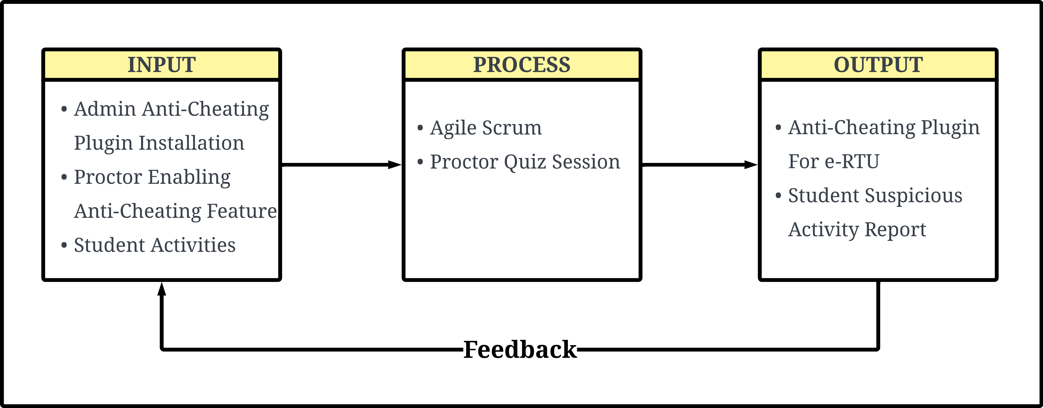

**DIAGRAM 1**

The anti-cheating plugin is installed by the e-RTU admin, making the auto-proctor feature available only to e-RTU users. Proctors have the option to enable auto-proctoring for all their quizzes. When students take quizzes with auto-proctoring enabled, they are required to activate video and audio inputs and select which screen or tab to share or focus on. The auto-proctor will capture all suspicious activities, including unusual student movements, loud noises, and switching tabs or screens. Once students submit the quiz, the auto-proctoring will be terminated, and all captured activities will be reported to the proctor.

**OPERATIONAL DEFINITION OF TERMS**

For a better understanding and clarity about the study, the important terms and concepts are defined.

**Database:** A structured data collection that can be readily accessed, managed, and updated.

**Cheating:** any unauthorized, dishonest, or deceptive action or practice undertaken by a test-taker with the aim of gaining an unfair advantage or misrepresenting their knowledge, skills, or abilities during the assessment.

**AI-based proctoring:** a technologically advanced approach that relies on artificial intelligence (AI) algorithms and systems to monitor and supervise online assessments, examinations, or tests.

**Plug in:** in the context of a Learning Management System (LMS) refers to a software component or module that can be seamlessly integrated into the LMS framework to extend its functionality or add specific features. These modular additions enhance the overall capabilities of the LMS, allowing for customization and adaptation to the unique needs of educators, administrators, and learners.

**e-RTU:** is a LMS platform used by Rizal Technological University for managing and delivering educational content, resources, and activities. It serves as a Learning Management System (LMS) to facilitate online learning, collaboration, and communication between students, faculty, and administrators.

**LMS (Learning Management System):** An educational software application or web-based platform specifically developed to facilitate and oversee educational procedures. It commonly encompasses functionalities for delivering courses, managing content, evaluating performance, facilitating collaboration, and enabling communication within an online learning setting.

**CHAPTER II**

**REVIEW OF RELATED LITERATURE**

This chapter includes studies and past literature that helped support the current study and widen the perspectives of the proponents. The enlisted studies became the foundation of the current project and helped the proponents to conduct the study with ease and accurate information.

**Traditional Proctoring**

As academic evaluation and examination monitoring have evolved, traditional proctoring has remained essential in ensuring the integrity and credibility of exams in educational institutions worldwide. In its traditional form, this process involved a physical proctor supervising students during exams and closely monitoring their behavior to prevent cheating or unauthorized help. However, with the growth of technology, traditional proctoring has adapted to incorporate online and remote methods while still maintaining its essential goal of upholding the credibility of academic evaluations. With these changes, traditional proctoring will continue to play a vital role in ensuring fair and honest academic assessments for years to come.

According to (Amigud et al., 2018), one of the most common methods for ensuring identity is proctoring. Naturally, when proctoring works (and is proven to work), potential cheaters are discouraged, and cheating becomes less common; nevertheless, if it has adverse side effects that potentially outweigh the favorable advantages, there is cause for concern. These adverse side effects may have a technological basis, such as the fact that it needs to be clarified how many false positives the proctoring procedure will generate due to a lack of performance statistics for proctoring systems.

Examinations in a traditional setting have long been a challenge for educational institutions due to the prevalence of cheating among students. Proper observation and proctoring are required to ensure the integrity of these exams. In such settings, cheating can take various forms, such as whispering or mouthing answers, exchanging scripts or small pieces of paper, bringing in answers written on body parts or clothing, sneaking in phones and other digital devices, or even attempting to peek into another student's script, also known as "Girrafing." Trained proctors typically monitor these activities through physical frisking and bag checks, random seating arrangements, and the use of CCTV cameras as a deterrent. Overall, these measures are taken to ensure that students are aware that they are being monitored and that cheating will not be tolerated (Njuguna, 2022).

One of the significant academic difficulties for the majority of university departments has historically been the administration of examinations. According to Wen et al. (2023), traditional examination settings rely on invigilators for real-time monitoring of examinees, often enhanced by using cameras to aid invigilation. However, this approach is susceptible to incomplete monitoring and insufficient cheating detection. Despite alternative approaches emphasizing active and authentic activities for building knowledge, traditional examination methods such as closed-book, time-constrained, invigilated, and multiple-choice exams continue to dominate in higher education. These traditional exams are considered secure and are believed to prevent unethical student behavior, mainly cheating (Bengtsson, 2019).

**Online Education during the COVID-19 Pandemic**

The COVID-19 pandemic has profoundly impacted education systems globally, necessitating the closure of schools and universities and the rapid shift to online learning. This transition presented significant challenges for students, teachers, and administrators, requiring adaptation to a new educational landscape. These closures affected nearly 188 countries and approximately 900 million learners worldwide, threatening the right to education, as highlighted by UNESCO (Nicola et al., 2020; UNESCO et al., 2020). This research examines the implications of this shift and explores the opportunities and challenges of online education in the context of the pandemic.

During the COVID-19 pandemic, the Philippines witnessed the rise of online education as a pivotal alternative to conventional in-person learning. As the world grappled with the challenges posed by the pandemic, educational institutions in the Philippines were compelled to swiftly adapt to ensure the seamless continuation of learning for students at all educational levels. Online education took precedence as the primary mode of instruction, with students, educators, and educational establishments transitioning to virtual platforms for delivering and receiving lessons. This shift towards online learning presented many opportunities and challenges, encompassing concerns about equitable access to technology, internet connectivity, and the necessity for pedagogical innovation. It highlighted the critical significance of digital literacy while highlighting the disparities in educational resources nationwide. Like many other nations, the Philippines grappled with its distinct circumstances as it endeavored to deliver high-quality education amid a global health crisis. The sudden transition to online learning during the COVID-19 pandemic also highlighted limitations in preparedness (Sintema J, 2020). While some instances of successful online education existed, they were often isolated and insufficient to address the magnitude of the global crisis. The lack of technological infrastructure in certain regions exacerbated the difficulties faced by educational institutions.

Substantial infrastructure for online education existed in many countries before the pandemic (Mishra et al., 2020). However, universities still needed to be ready for a complete shift to online education. Empirical studies have found that students learn better in physical classrooms than in online education (Bojovic et al., 2020).

On the other hand, the successful utilization of online education tools and platforms showed promise, especially with the increased use of language apps, virtual tutoring, and video conferencing tools (Andress et al., 2020; Kelly, 2020). These tools facilitated education and made the learning process more engaging and enjoyable. One of the remarkable advantages of technology in education is its alignment with the learning styles of Generation Alpha and Generation Z children. Online education has proven highly suitable, particularly for the tech-immersed Generation Z and the even more tech-immersed Alpha generation (Renton & McCrindle, 2020). Understanding the characteristics and preferences of these generations is vital, as they are at the forefront of shaping the social media landscape and influencing popular culture. The attributes of Generation Z, including self-awareness, confidence, innovation, and comfort with a digital lifestyle, present unique implications for education, from virtual reality training to problem-solving (Renton & McCrindle, 2020).

In light of the COVID-19 pandemic, education has become increasingly dependent on technology and online learning. This shift has brought both the advantages and disadvantages of digital education to the forefront. While technology can offer innovative and engaging learning experiences, it also presents connectivity, engagement, and interaction challenges. Understanding the unique needs and preferences of Generation Alpha and Generation Z is crucial as they navigate this digital educational landscape. As we move forward, it is essential to address the limitations of technology in education and ensure that all education components are not solely reliant on advanced technology to mitigate potential risks. Like many other nations, the Philippines also grappled with its distinct circumstances in embracing online education during a global health crisis, highlighting the need to address specific challenges and ensure equitable access to education resources (CHED, 2020; Goldschmidt, 2020).

Professors are now delivering course content through various platforms. Professors use online educational platforms, video-conferencing software, and social media to teach their courses (Patricia, 2020). Online educational platforms, like Google Classroom and Blackboard, allow professors to share notes and multimedia resources related to their courses with students. Online educational platforms also allow students to turn in their assignments and professors to keep track of the progress of the students. Video conferencing tools, like Google Meet, Zoom, and Microsoft Teams, help organize online lectures and discussion sessions. Such tools typically support slideshows and a chat box. Some universities also disseminate course material through their websites (Chatterjee & Chakraborty, 2020) and their learning management system (Mishra et al., 2020).

**Online Proctoring**

In an era marked by technological advancements and the ever-expanding influence of the internet, online education has firmly established itself as an integral component of the educational domain. The convenience of remote education has granted students and professionals worldwide access to diverse courses and programs, all from the comfort of their homes. As the accessibility and convenience of virtual learning platforms continue to expand, there is an escalating demand for reliable assessment methods that can preserve academic integrity.

In the ever-evolving education landscape, online learning platforms have revolutionized knowledge acquisition. Online proctoring has emerged as a pivotal solution to this challenge, fundamentally transforming the approach to conducting assessments and examinations in the digital age.

One online proctoring company switched from having 100 customers per year to having 120 customers per day (Drew, 2020). Although there has been a vast movement toward online proctoring, schools still expect to "have larger measurement errors than usual" (Burgess & Sievertsen, 2020).

Many educational institutions have shifted to online learning due to the COVID-19 pandemic. Universities started using online proctoring tools to administer online exams. However, there are some disadvantages to using online proctoring, including concerns about misconduct and cheating during online exams. Therefore, there is a need to provide guidelines for the online proctoring approach for students and teachers to maintain ethical standards and academic integrity (Sando et al., 2021).During the pandemic, an online exam played an essential role in an E-learning ecosystem. The proper design of online assessments plays a significant role in their effectiveness. Online exams are typically performed on a learning management system (LMS) without the physical participation of students and teachers in the exact physical location (Muzaffar et al., 2021).

During the COVID-19 pandemic, online exams have become increasingly popular for evaluating students' knowledge. Hence, the use of online proctoring tools also increased to a more significant extent. Due to the lack of face-to-face contact, proctoring online exams is challenging (Li et al., 2021).

Academic dishonesty is unavoidable at each stage of student assessment. Many studies concluded that cheating occurs mainly in the unproctored environment, while other studies reported increases in the proctored environment (Dendir & Maxwell, 2020; Gamage et al., 2020; Ikram & Rabbani, 2021).

Measures like providing no extra time, reducing multiple-choice questions, randomizing question patterns, and using plagiarism checkers with proctoring tools can reduce cheating (Goldberg, 2021). Students face other challenges during online proctoring: browser incompatibility, anxiety about the online exam, and slow internet connection (Alkamel et al., 2021; Cahapay, 2021).

Online proctoring programs, sometimes called remote proctoring, generally refer to digital techniques for monitoring and controlling student activities during an exam through webcams and internet connections (Hylton, 2016), thus preventing and detecting any possibility of malpractice.

**Development of Online Examination Platforms**

Online learning technology has significantly increased in the past several years. Universities have had to invest more in technology to improve student learning and efficiency while also improving their competitiveness. However, relatively few research have looked at how university students would embrace and utilize smart devices as a new testing platform. The COVID-19 pandemic has forced schools to adapt to a new reality of distant learning, increasing the adaptation of digital and mobile approaches to education. According to Alshurideh et al. (2021), integrating mobile examination platforms has positively affected students' academic achievement. These platforms offer various advantages over classroom examination systems, including portability, wireless connectivity, and sensitivity. Kahoot is a popular mobile examination platform used for education and to provide live tests in the classroom to evaluate student learning is "Kahoot." This platform helps to develop and distribute questions to students to assess their progress in learning. Kahoot offers a wide range of question formats, such as polls, tests, riddles, and slides, and facilitates the evaluation process for both teachers and students. Teachers prefer the mobile examination platform since it displays results immediately after the exam and automatically calculates students' scores (Lalitha & Periasamy, 2018).

Many nations have struggled to transition to a fully digital society as the pandemic has progressed. This development is expected to transform the educational environment, allowing professors and students to collaborate in different locations (Singh & Thurman, 2019). According to research, the effectiveness of e-learning platforms can be viewed from two different perspectives. The first perspective is concerned with the simple acceptance of technology. It uses the technology acceptance model (TAM) to assess the functionality and accessibility of e-learning platforms, thus evaluating the level of acceptance of the technological aspects. On the other hand, the second perspective is focused on situation awareness and examines how the context of instruction influences students' acceptance levels. In conclusion, studies on online learning platforms have primarily used technology acceptance (Sánchez-Prieto et al., 2019), flow theory, and the unified theory on acceptance and use of technology model to examine the effectiveness of e-learning platforms before and after the pandemic (Al-Maroof et al., 2021).

The online examination platform is rapidly gaining popularity due to its convenience, efficiency, and reliability as an examination technique. Web-based platforms are the most specific option for educational institutions such as schools, colleges, universities, coaching courses, training facilities, certification agencies, and recruiting organizations to administer timer-based tests that are fully automated and paperless. The virtual examination system consists of modules for question banks, exams, test preparation, administering exams, computing results, viewing results, storing test data, and an administrator module for managing exams, questions, and alternative options. It is essential for organizations to effectively allocate time in order to properly prepare students for examinations (Badve et al., 2022).

Online examination is an integral part of E-learning solutions for the genuine and fair assessment of students' performance. The design and execution of online exams are the most challenging aspects of E-learning. Mainly, online exams are usually conducted on E-learning platforms without the physical presence of students and instructors at the same place.

**Online Cheating**

In the digital era, the proliferation of online platforms and technologies has significantly impacted how people interact, learn, and conduct various activities. However, this expansion of the online landscape has given rise to deceptive behavior and misconduct, with online cheating becoming a prevalent concern across different domains such as education, gaming, business, and personal relationships. This review explores the multifaceted dimensions of online cheating, including its manifestations, underlying motives, and strategies to combat it.

Recent years have witnessed the development of proctoring technologies designed to secure online exams, such as identity authentication, keystroke recognition, and webcam proctoring (Xiong & Suen, 2018). Other techniques complement these technologies, including controlling the browser, limiting exam time, and randomizing questions and choices. However, despite these measures, cheating remains a common issue in online courses (Dendir & Maxwell, 2020).

Cheating on exams is widespread among college and university students, and this trend is not limited to the United States. Students often face academic pressure to achieve high grades and graduate with honors to secure job opportunities. Many universities now require students to use cameras to record themselves during exams to curb cheating. However, some students argue that these rules conflict with their privacy rights, raising critical ethical considerations.

The COVID-19 pandemic accelerated the transition to online education. The abrupt shift, combined with the anxiety surrounding higher education's preservation, left students in a state of urgency, making some more prone to engaging in cheating and plagiarism. Bilenand and Matros (2021) noted a surge in online cheating during the pandemic, especially as many educational institutions did not mandate students to turn their cameras on.

Practitioners in higher education have proposed solutions to address reduced accountability for cheating in online exams. One such solution is proctoring, ensuring academic integrity with methods such as live observation via webcam or delayed checks for fraudulent behavior through recordings. Results from empirical research indicate that proctoring online exams reduced the inflated performance rates observed in online exams without proctoring while also enhancing the perceived accountability for academic dishonesty (Janke, Rudert et. al 2021).

However, several factors can deter instructors from using strategies to mitigate cheating, starting with a lack of knowledge about these procedures, a lack of motivation to implement them, and technical issues such as a lack of access to proctoring software. This was likely a problem during the onset of the COVID-19 pandemic when higher education instructors with little experience and restricted time had to familiarize themselves with online testing. In contrast, higher education institutions often still needed more technical expertise and the legal foundation for specific methods, such as proctoring (Petersen and Fritz 2021).

The issue of digital cheating, which refers to a range of deceitful behaviors involving computer technology, has emerged as an increasingly worrisome phenomenon within this particular domain. One manifestation of academic dishonesty in the digital realm is "e-cheating," which involves using the Internet to facilitate cheating. These practices encompass instances of term paper plagiarism and dishonest behavior during web-based examinations, as documented by reputable sources in the media. Lieneck (2018) found that online and social media tools outside the scope of the online course site are used by 67% of students to help with their studies, further highlighting the pervasive nature of digital cheating in the online education landscape.

**Use of AI in Cheating During Online Examination**

In recent years, there has been a notable transition towards online learning within higher education, a movement that the global COVID-19 pandemic has further carried out. This industry transition to digital platforms has increased concerns regarding academic integrity (Barber et al., 2021; Whisenhunt et al., 2022; Garg & Goel, 2022). The emergence of online examinations has generated concern over the possibility of dishonest behavior and other manifestations of academic misconduct (Ahsan et al., 2021; Crook & Nixon, 2021; Noorbehbahani et al., 2022; Henderson et al., 2022). The occurrence may be linked, to some extent, to the fundamental characteristics of online examinations, such as anonymity and limited direct supervision, as well as the convenience with which students can access and exchange resources throughout the examination.

In the world of artificial intelligence, ChatGPT is a substantial language model that uses deep learning to analyze and produce text in a manner that resembles human language. It has been trained using vast amounts of written data, enabling it to understand the complexities and intricacies of human language. As a result, ChatGPT presents an exceptional challenge to the preservation of academic integrity.

One of the primary benefits of these expansive language models is their capacity to comprehend the contextual variations of a provided prompt and then produce suitable answers. ChatGPT has a high level of reasoning complexity and proficiency in addressing challenging university-level inquiries across several academic fields. It has been noted that ChatGPT demonstrates the capacity to articulate its solutions clearly and cohesively (Vaswani et al., 2017).

According to Susnjak (2022), ChatGPT is a remarkable achievement in artificial intelligence. It could revolutionize how we communicate and interact with technology. The possibilities for its use are endless, from assisting with research and writing to providing customer support and beyond. Despite its many benefits, ChatGPT poses a challenge to academic integrity, and it is essential to ensure that its use is carefully monitored to prevent misuse or abuse.

Barber et al. (2021) state that academic misconduct, encompassing acts such as plagiarism and cheating, poses a significant apprehension for institutions of higher education and educators equally, regardless of whether assessments are conducted in traditional face-to-face settings or through digital platforms. Academic dishonesty is prevalent in educational institutions, spreading from primary schools to colleges and universities. The growth of technological advancements, particularly the emergence of Artificial Intelligence (AI)-driven platforms like ChatGPT, has significantly facilitated the act of academic dishonesty, making it more accessible than ever. Cheating involves a wide range of behaviors, including but not limited to plagiarism and engaging in dishonest practices during examinations. A considerable number of students fail to perceive cheating as a substantial issue, with a subset even endorsing it as a permissible means of attaining high academic performance (Ventayen, 2023).

**Development of Plug-ins**

As we continue to advance technologically, web-based applications have become a staple in our daily lives. With numerous web-based applications available, it is now possible to integrate third-party server-side plugins that offer a wide range of functionalities. In order to manage the specific requirements and handle various circumstances, web applications facilitate the integration of server-side plugins, which can be provided by different organizations and offer different functionalities. This integration allows users to access a wide range of features, making it easier to complete tasks and achieve their goals (Fonseca & Vieira, 2014).

(Henge et al., 2023) states that plug-ins prioritize the security and privacy concerns of third-party libraries and plug-ins on different platforms. Evaluating the security and privacy aspects of applications by considering factors such as how users perceive their performance, the access they have to hardware and data, the user interface and overall appearance, the ease of deploying them in the marketplace, the prevalence of the technologies they use, the availability of APIs in both software and hardware, their ability to integrate with other systems automatically, and the number and level of integration of software libraries. The significance of overseeing third-party libraries and plug-ins is to guarantee programs' security and privacy across diverse contexts. Establishing regulations to govern and regulate limited TPLs and plug-ins according to particular criteria is essential in reducing the possible hazards linked to unapproved third-party libraries and plug-ins.

The evolution and significance of plugins within web and software development have sparked numerous investigations and best practices, marking a substantial area of scholarly exploration. Specifically in web development, the focus has been directed towards the intricate workings of plugins within plugin-based web systems, prominently exemplified by WordPress.

One noteworthy study delved into the vulnerabilities inherent in plugin-based web systems, illuminating critical insights into the security dimensions entwined with plugin development (Mesa et al., 2018). This research shed light on the potential risks associated with plugins, underscoring the imperative need for fortified security measures in their creation and implementation. Moreover, case studies have been meticulously undertaken within the expansive domain of web development, honing in on creating plugins tailored for precise objectives. For instance, Fitzgerald (2022) conducted a compelling case study on fashioning a custom post type tailored explicitly for case studies within the WordPress framework. Such case studies serve as invaluable guides, offering practical insights into the nuanced process of crafting purpose-built plugins to meet specific requirements.

In software development, research efforts have ventured into optimizing the software development lifecycle by integrating plugins seamlessly with project management tools like Jira (Staff, 2023). This exploration emphasizes the integration of plugins into established project management frameworks, thereby streamlining and enhancing the overall development process. A treasure trove of best practices and expert guidance has been proffered to illuminate the path for plugin and workflow development across diverse platforms. Notably, Jowells (2022) laid a comprehensive guide for effective plugin and workflow development on the Microsoft Dataverse platform. The discourse highlights crucial aspects such as the implementation of stateless plugins and the judicious utilization of the ITracingService, serving as a beacon for developers navigating the intricate landscape of plugin creation within the Dataverse ecosystem. Collectively, these studies and practices encapsulate the expansive terrain of plugin development, illuminating its multifaceted nature and underscoring its pivotal role in augmenting web and software development landscapes.

**Tool Development for Anti-Cheating during Examinations**

Academic dishonesty, mainly cheating on examinations, is a widespread issue that educational institutions worldwide aim to address. As a result, the integrity of examinations has become a top priority in the educational landscape. Developing tools that can detect and prevent students from cheating on tests is an essential component of this initiative. These tools include a wide variety of technologies and approaches, all of which aim to prevent and identify dishonest practices during examinations. Online examination platforms can benefit significantly from the integration of automated proctoring solutions. These systems use computer vision and machine learning algorithms, with face verification frequently playing an essential role in the system as a whole. In addition, they use object detection to keep an eye out for any anomalies that may occur during the examination (Kamalov and Firuz, 2021). These automated proctoring systems represent a technological innovation created for the purpose of monitoring and overseeing online exams or assessments. In remote or online education settings where traditional in-person proctoring methods are impractical, AI proctoring serves as an alternative solution to guarantee academic integrity and discourage instances of cheating.

Students who take exams at home are held to a higher standard of independence in their work, but many try to get around the rules by resorting to digital cheating or contract cheating. Universities use various tools to combat exam cheating, such as remote proctoring, webcams, LockDown Browsers (such as Respondus), and plagiarism software (such as Turnitin, SafeAssign, and iThenticate). Monitoring software is also used while students are undergoing examinations (Ozgen and Ozturk, 2021). According to the research of King and Case, more than 74 percent of students have the misconception that it is simple to cheat on online exams. Exams are typically subjected to the traditional form of proctoring, which entails human monitoring. This is done to guarantee the validity of the tests. However, since it requires keeping an eye on people to make sure they aren't cheating, this approach takes a lot of time and effort on the workers' part.

Several research papers have categorized online proctored exams in different ways, offering insights into the various methods employed to maintain exam integrity. For instance, Nigam, et al. (2021) categorized proctoring software in general into Live Proctoring, Recorded Proctoring, and Automated Proctoring. Nie, et al. (2020) recommended that live proctoring is more accurate for online proctoring because it does not limit the invigilation process to remote monitoring. Live proctored exams are different from automated proctored assessments. Raman, et al. (2021) notes that the former examinees must wait for the specific scheduled time before they can take their exams. This means that many students must undertake an exam at the same time. The method has various challenges that limit its accuracy in online proctoring.

Furthermore, Ong and Lee introduced an innovative anti-cheating intelligence agent in their study. This agent utilizes a relationship model and employs AI techniques, including an IP detector and a behavior detector that uses the Long Short-Term Memory (LSTM) network with a densely connected concept known as DenseLSTM. These advanced AI techniques enhance the capabilities of online exam security and contribute valuable insights to the field of intelligent tutoring systems, further advancing the fight against cheating on exams. In summary, the academic community has recognized the need for innovative proctoring methods, whether live or automated, to address the challenges posed by online exam cheating and maintain academic integrity.

**Online Proctoring vs. Traditional Proctoring**

In today's rapidly evolving educational landscape, assessment and examination methods have undergone a substantial transformation. Traditional proctoring, which involves an individual invigilator monitoring test-takers in person, now confronts a significant challenge in online proctoring. This technology-driven approach harnesses the internet's capabilities to supervise remote assessments. As technology continues to permeate every aspect of education, it becomes crucial to explore and understand the critical distinctions between these two proctoring methodologies.The contrast between online and traditional proctoring methodologies highlights the life-changing developments within the education sector. The growing adoption of technology has prompted a substantial reevaluation of assessment and examination methodologies. The traditional proctoring methods have historically focused on in-person monitoring to maintain academic integrity. However, the emergence of online proctoring has provided a new approach that utilizes digital technologies to supervise examinations conducted remotely. As educational associations confront the necessity of maintaining integrity and security during technological advancements, it becomes evident that a thorough understanding of the benefits and constraints of each proctoring approach is crucial for making well-informed choices regarding implementation. The comprehension of this concept is of most significance in maintaining the credibility and effectiveness of evaluation methods within the constantly changing world of contemporary education.

**CHAPTER III**

**TECHNICAL BACKGROUND**

This chapter demonstrates the technicality of the project which includes the methodology, frameworks, procedure and flow of the proposed project, technology to be used and its requirements all of which will contribute to the development of the plugin.

**TECHNICALITY OF THE PROJECT**

The proponents of the Anti-cheating plugin will utilize several technologies, primarily web-based applications. However, the hardware and software utilized are subject to changes and enhancements throughout the development process, as the project is still in its preliminary phase.

The proposed project is AI based anti-cheating plugin to be integrated in RTU’s LMS kown as e-RTU to ensure supervision and prohibit academic dishonesty during examinations. In this project, certain terminologies were defined to help individuals from different fields understand easily. The terms WLAN, Text Editor - VS Code, Components of Web Development – PHP Laravel, HTML, CSS, and JavaScript, Framework – Tailwind and Flowbite, Database – XAMPP, MySQL and PhpMyAdmin, Collaboration – Git and GitHub, Design Tools - Figma, Lucid Chart, Canva and Photoshop are used by the proponents to develop the project.

**TECHNOLOGY USED**

**Network**

**Wireless Local Area Network (WLAN)**

WLAN is a wireless computer network that uses high-frequency radio waves to connect two or more devices instead of wiring. This technology enables the establishing of local networks within residential and commercial premises without the need for physical Ethernet cable infrastructure. Wireless Local Area Networks (WLANs) cannot be constrained by the number of physical ports available on the router, enabling them to accommodate numerous devices, ranging from dozens to perhaps hundreds.

**Text Editor**

Visual Studio Code, developed by Microsoft, is a widely utilized source code editor by developers for writing, editing, and debugging code in various programming languages. It has user-friendly interface and wide range of features that can enhance workflow efficiency such as build and scripting tools.

**Components of Web Development**

Laravel is an open-source PHP framework that offers various functionalities that incorporates the basic features of PHP framework that boosts the speed of web development. HTML plays a fundamental role in the plugin by providing the underlying structure for content and layout. In addition, Tailwind and Flowbite serve as style frameworks that facilitate the customization of visual elements inside the plugin, encompassing aspects such as layout, fonts, color schemes, and positioning. Moreover, JavaScript places a greater emphasis on plugin’s interactivity. Putting all these components together allows developers to create interactive and visually appealing interfaces.

**Database**

**XAMPP**

An open-source cross-platform web server that is primarily designed for development and testing. The platform offers a suitable environment for conducting tests on projects involving MYSQL, PHP, Apache, and Perl. Additionally, this allows developers to test their programs on a local webserver without worrying about connectivity to an outside server.

**MySQL**

My Structured Query Language is a widely utilized open-source database management system. The platform has gained popularity because of its significant attributes of speed, dependability, and user-friendliness, making it a preferred option for web applications and diverse software systems. SQL, a part of MySQL, is a standardized language that enables users to store and retrieve data effectively.

**PhpMyAdmin**

PhpMyAdmin is a web-based administrative tool designed specifically for managing MySQL databases. It is an essential tool as it provides a graphical user interface (GUI) to interact with these database management systems, enhancing user convenience in executing diverse database-related operations without using the command-line interface.

**GIT**

Git, a distributed version control system, allows developers to have a full copy of the anti-cheating plug-in code repository on their local machines. This functionality significantly facilitates individual work and collaborative efforts with other developers involved in the same project. A standout feature of Git is its effective code change monitoring. It maintains a detailed history of the codebase in the form of a directed acyclic graph (DAG). This structure simplifies the visualization of how the code has evolved and provides the flexibility to revert to previous versions when necessary. Git's non-linear version control capabilities further enhance its utility. Additionally, the developers have the option to create branches for experimenting with new features or addressing bugs without compromising the integrity of the main codebase. These branches can seamlessly integrate into the primary codebase, ensuring an organized and efficient development process.

**GitHub**

The utilization of GitHub presents substantial advantages to the development of the anti-cheating plug-in. It serves as a highly efficient platform for version control, collaboration, and project management. The hosting of the code repository on GitHub ensures that the development team has access to the most current codebase, fostering seamless project collaboration. GitHub streamlines the tracking of changes, facilitating a clearer understanding of how the code evolves over time. Moreover, it provides a structured and organized environment for managing issues, tasks, and project milestones, thereby enhancing project management capabilities. GitHub's branching and pull request features empower developers to work on new features and bug fixes without disrupting the stability of the main codebase. This enables the team to maintain a reliable and up-to-date codebase while efficiently managing the development process. Additionally, GitHub promotes transparency and serves as a valuable tool for code review, ensuring high standards of code quality. In summary, the integration of GitHub into the anti-cheating plugin stands to significantly enhance development, collaboration, and project management, ultimately contributing to the success of the project.

**Design Tools**

Developed by Adobe, Photoshop is a software application used for the purpose of editing photos and designing raster images. This tool is valuable to the developers as it helps create visual elements that will contribute to the visual aesthetics of the plugin. Additionally, Canva, an online graphic design tool, serves the same purpose. With its extensive templates and a drag and drop interface, it is beneficial for those without design backgrounds. Moreover, the developers use Lucid Chart for creating diagrams and flowcharts. It has a user-friendly interface and allows real-time collaboration, enhancing the efficiency of the visual representation of the data and even the overall plugin flow. Together with Figma, a collaborative design tool, this helps developers to conceptualize design, putting up all designed elements to create the prototype for the plugin.

**How the Project Works**

The project was broken down into Sprints, following the Agile Scrum methodology. During the project's initial phase, developers determine the purpose and objectives, followed by which technology to use, before presenting it to the respective client. Documentation and plugin development will start upon the client's approval. Consequently, identifying crucial features and functionality necessary for the prototype was also undertaken. The subsequent phase will involve developing and testing the beta version progressively implementing the plugin’s functionalities. Nevertheless, there is still a chance that bugs, and other issues will arise throughout the development process, which means that the plugin’s functionality and operational stability still need to be guaranteed.

Following the development phase is the plugin implementation phase, during which, once the client has approved the plugin, the process will now proceed to deploying the approach to the desired environment, making it accessible to users, and ensuring that it performs as designed. In addition, a user manual will be made available to end users so that it can better assist them in comprehending the full function of the plugin.

**CHAPTER IV**

**METHODOLOGY USED**

In this project, the proponents follow Agile Scrum approach that outlines and divides the project into smaller phases. This method entails a collaborative effort in which, from planning to plugin implementation, the proponents will be working on specific tasks and responsibilities iteratively and progressively. Moreover, due to time constraints, this method instills a sense of urgency by using Sprints, which sets a timeframe, allowing tasks to be prioritized according to their urgency. With that, daily meetings are set to discuss every progress and eliminate possible roadblocks.

**Environment**

**Locale**

The project is specifically targeted for Rizal Technological University Boni Campus, located in Mandaluyong City. The researchers are working towards creating an Anti-cheating plug-in that will be incorporated into Rizal Technological University's learning management system, E-RTU. The E-RTU is an e-learning platform based on Moodle, specifically designed for distance learning. It provides a platform for a wide range of online courses offered by different academic departments within the institution, ranging from Laboratory High School to Graduate School. The study was designed to facilitate professors in promptly identifying students who engage in cheating during tests, enabling students to proactively deter any suspicious behavior during exams, and to assess their knowledge by closely monitoring every action done during assessments. Furthermore, this provides the university with an AI-integrated plug-in that can be utilized for its LMS.

**Population of the Study**

The Anti-cheating plug-in has been specifically developed to meet the needs of instructors and students in the IT Department of Rizal Technological University. This aims to gather valuable data from faculty members and students, with its usage limited solely to the IT department. The main goal is to improve the academic integrity in IT courses by integrating an anti-cheating plug-in to the university’s LMS. The researchers aim to collect relevant information, insights, and comments exclusively from the academic community inside the IT department to ensure the effectiveness and suitability of the plugin in this academic context.

**Organizational Chart/Profile**

**Requirements Specifications**

**Operational Feasibility**

**Technical Feasibility**

The researchers will evaluate the hardware and software components of the gadget to ascertain their capacity to effectively execute the program. In order to ensure optimal performance of the plug-in, users must adhere to the minimal requirements indicated in the tables below prior to deploying the plug-in.

**Compatibility Checking**

Researchers will verify the compatibility of the hardware and software with the user's device, ensuring that the developed plug-in can operate seamlessly and synchronize both components without any errors. This is crucial to avoid web crashes and other potential issues that may occur if the final product is not properly configured or tested for compatibility.

|  |  |  |
| --- | --- | --- |
| **Hardware Specification** | | |
| **Component** | **Minimum Requirements** | **Recommended Requirements** |
| **Display Resolution** | **1024x768 or higher** | **1366x768 or higher** |
| **Processor** | **Intel Core i3 or equivalent** | **Intel Core i5 or equivalent** |
| **RAM** | **4GB** | **8GB or higher** |
| **Storage** | **128GB HDD/SSD** | **256GB SSD or higher** |
| **Internet Connection** | **WIFI/LAN Connection** | **WIFI/LAN Connection** |
| **Microphone** | **Basic microphone** | **Noise-canceling microphone** |
| **Camera** | **Basic webcam** | **HD webcam** |

|  |  |  |
| --- | --- | --- |
| **Software Specification** | | |
| **Operating System** | **Windows 10, macOS 10.13** | **Windows 10, macOS 10.15** |
| **Browser** | **Google Chrome, Mozilla Firefox, Safari** | **Google Chrome, Mozilla Firefox, Safari** |

The table provided contains a comprehensive set of system specifications necessary for the smooth and successful execution of the plug-in. The list encompasses specs for the following components: display resolution, CPUs, memory, storage, internet connection, microphone, camera, operating system, and browser. It is vital to bear in mind that the researches precisely selected and tested the specifications to ensure the system functions flawless and without any glitches or issues.

**Relevance of Technologies**

|  |  |
| --- | --- |
| **Software** | |
| **VScode** | **is an extensively utilized source code editor that is well-known for its comprehensive debugging capabilities, wide-ranging language support, and extensibility. Because of its robustness and seamless integration with version control systems, it is highly regarded among developers.** |
| **Figma** | **A web-based design tool facilitates interface design, prototyping, and collaborative work. The real-time collaboration features of this software enable numerous users to work together on design projects at the same time, which makes it a preferred option for design teams.** |
| **Canva** | **A visual design platform, provides a user-friendly interface and a comprehensive collection of templates and design components. It enables the production of diverse visual materials, such as presentations, social media graphics, and posters.** |
| **Adobe Photoshop** | **Is a robust raster graphics editor that is used for photo editing, graphic design, and digital art. Renowned for its comprehensive range of features, Photoshop continues to be an essential tool in the creative sector.** |
| **Github** | **A web-based platform that enables version control using Git and acts as a centralized hub for hosting code repositories. The collaborative capabilities of this tool, such as issue tracking and pull requests, are extremely important for software development projects.** |
| **Database** | |
| **Xampp** | **XAMPP, created by Apache Friends, offers a comprehensive set of web server solution stack. The software package comprises the Apache HTTP Server, MariaDB database, and interpreters for PHP and Perl scripts, addressing a wide range of requirements in web development.** |
| **Mysql** | **MySql is the most widely used open-source relational SQL database management solution. One of the best RDBMSs for creating web-based software applications is MySQL** |
| **PhpMyAdmin** | **an open-source administration tool, empowers users to manage MySQL and MariaDB databases through a user-friendly web interface. It facilitates database operations such as creation, manipulation, and SQL query execution.** |

**Schedule Feasibility**

**Gantt Chart**

**Economic Feasibility**

The analysis of the development in Anti-cheating Plug-in for E-RTU are considered and determined by evaluating whether the proposed plug-in is economically viable and feasible for the costs and benefits associated with its implementation.

**Cost and Benefit Analysis**

The table below shows all of the materials, including the publication costs and assets that is used to build the anti-cheating plug-in for E-RTU.

|  |  |
| --- | --- |
| **Development Cost Analysis: Anti-Cheating Plug-In For E-RTU** | |
| **Materials** | **Cost** |
| Laptop/Desktop | ₱20,000.00 or more |
| Mobile Phone | --- |
| Internet Connection | ₱1,500.00/Monthly |
| Computer Peripherals/Web Cam/Microphone | ₱200.00 or more |

**Table 0.0:** Total cost of the hardware

|  |  |
| --- | --- |
| **Development Cost Analysis: Anti-Cheating Plug-In For E-RTU** | |
| **Materials** | **Cost** |
| VSCode | Free |
| XAMPP/MySQL | Free |
| Cloud Hosting/GoDaddy | ₱1,179.00/Monthly |

**Table 0.0:** Total cost of the Software

**Benefits Analysis**

The benefits of Anti-Cheating Plug-in for E-RTU are:

* E-RTU has now an Anti-Cheating Plug-in that detects malicious activity of students while taking quiz/exam.
* Real-time update of activities of students.

**Requirements Modeling**

**Input**

**Process**

**Output**

**Performance**

**Control**

**PLUGIN DATA FLOW DIAGRAM**



**DIAGRAM 2**

This context diagram provides an overview of the process of the auto-proctoring plug-in. It illustrates the external entities that interact with it and the major data flows in and out of the plug-in. Additionally, through this diagram, this will help end users to understand interaction between the auto-proctoring plug-in and other external factors.



**DIAGRAM 3**

The Level 1 diagram is a graphical representation of the auto-proctoring plug-in that displays the core processes, data stores, data flow, and external entities involved in a process. It provides a high-level picture of how data transfers within and between different entities outside the auto-proctoring plug-in.

**PLUGIN FLOWCHART**



**DIAGRAM 4**

This diagram illustrates a comprehensive visualization of the intricate step-by-step flow inherent in the auto-proctor program, aiding in understanding its features. Through this diagram, end users can gain a more thorough understanding of the intricate flow that governs the auto-proctoring process.

**PROTOTYPE**

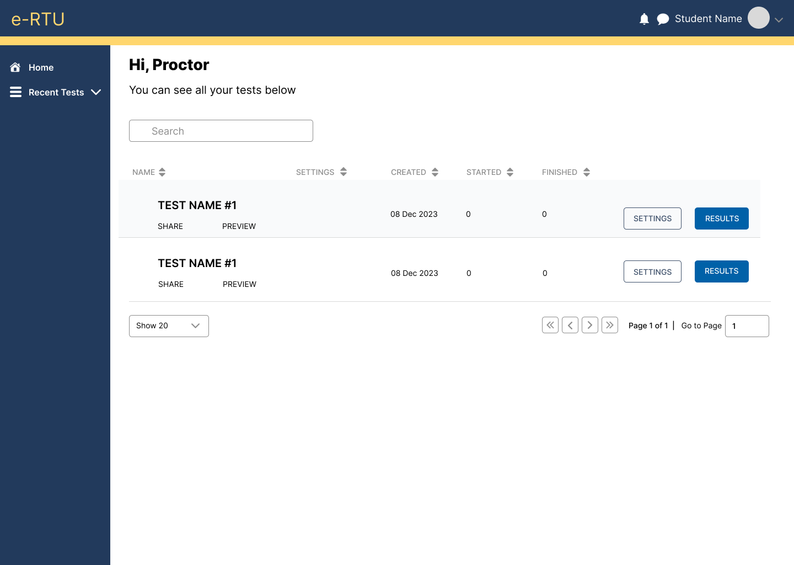

**FIGURE 1: Auto-Proctor Dashboard**

This figure shows a list of all created quizzes of the proctor. Two buttons are available for the quiz's settings and results, along with a search bar to look up a specific name.

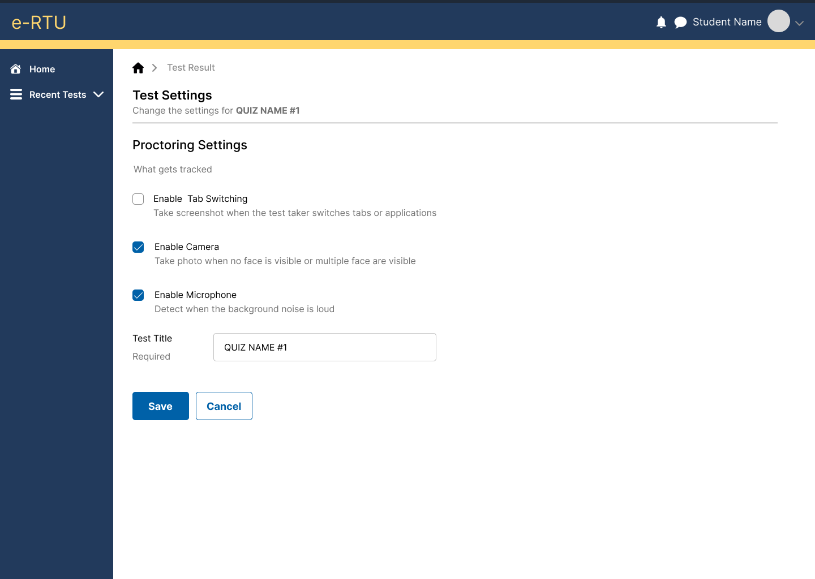

**FIGURE 2: Auto-Proctor Quiz Settings**

**FIGURE 2**

Clicking the settings button will reveal the interface above. The proctor can then select auto-proctoring preferences deciding whether to require the camera, microphone, or tab switching during the exam or quiz.

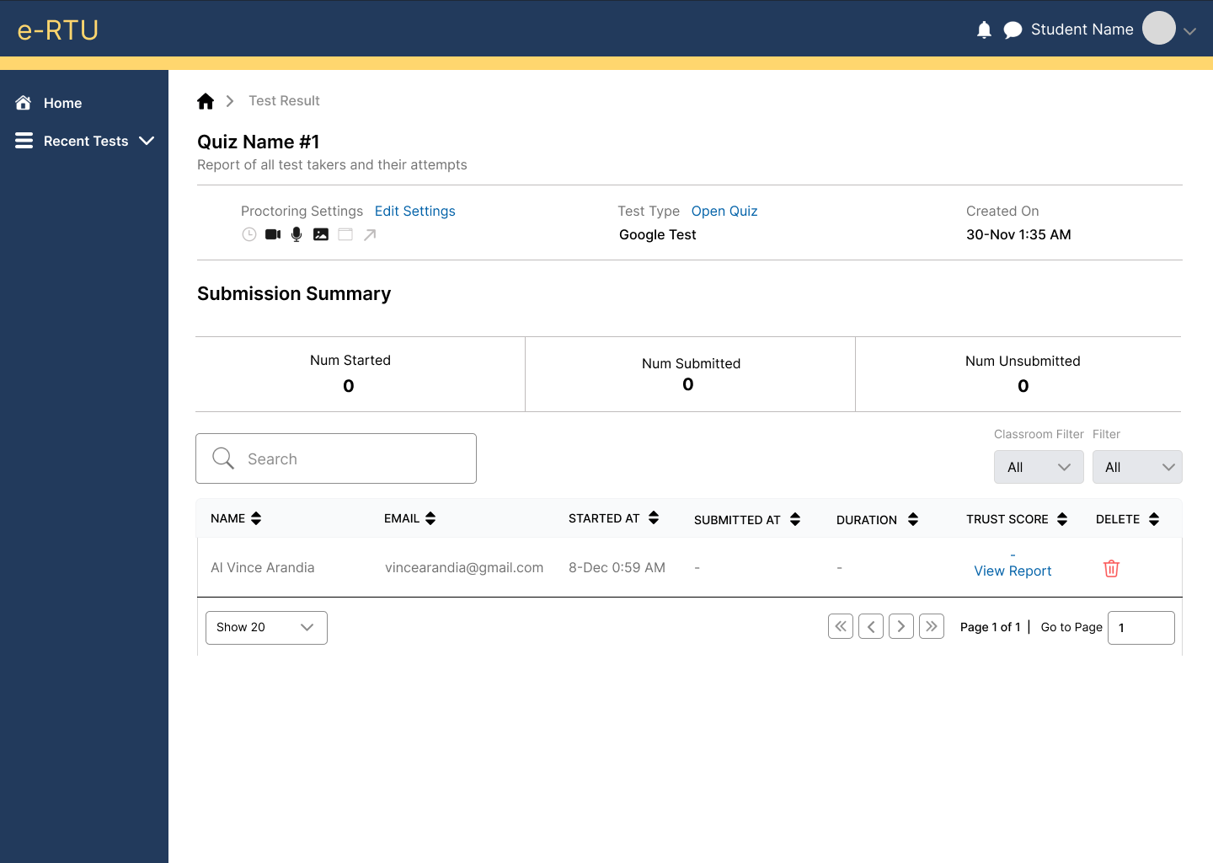

**FIGURE 3: Auto-Proctor Quiz Results**

**FIGURE 3**

In this section, proctors can see the quiz details such as the test type, the date of quiz creation, and the settings they selected for that exam or quiz. The quiz submission summary is also displayed here, with the list of students who turned in their quiz located below the summary. Additionally, proctors can access students’ activity report individually to review and see if the students cheated during the exam.

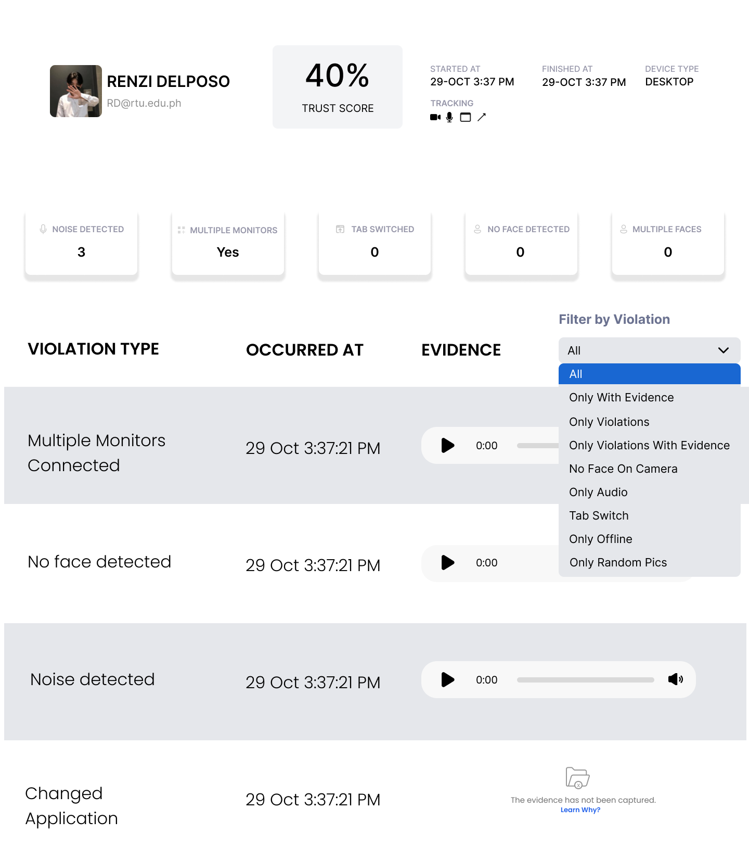

**FIGURE 4: Auto-Proctor View Report**

**FIGURE 4**

This figure is the proctor's view of a students’ suspicious activities. It displays student information, including name and account name, along with a list of their suspicious activities, their types, and, if available, captured evidence.

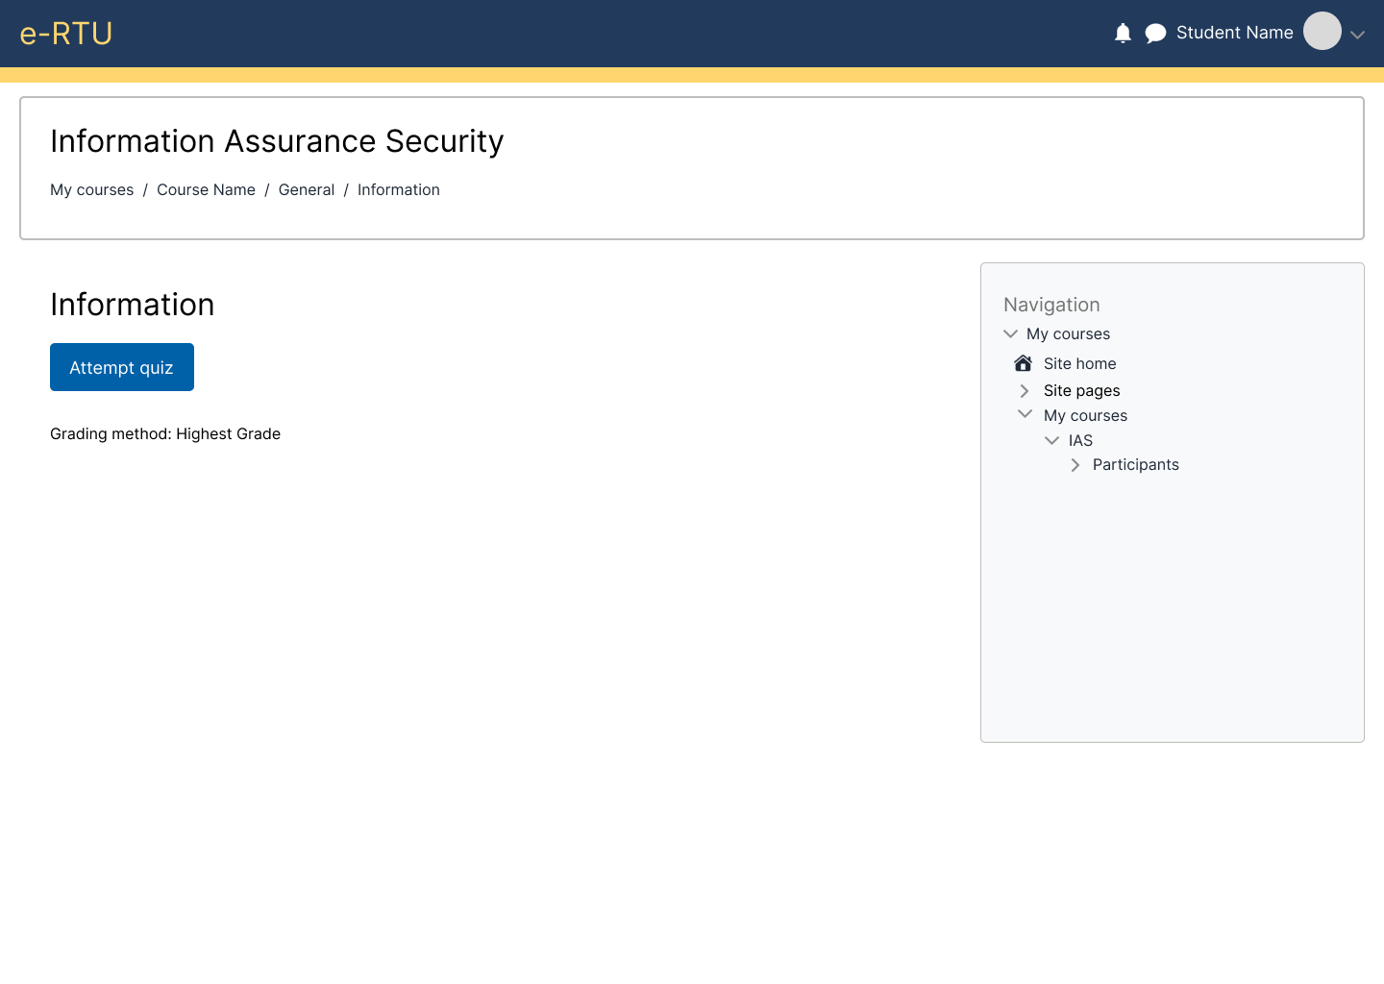

**FIGURE 5: Pre-Quiz**

This figure will appear before the student starts or attempts the quiz. Additionally, relevant details such as the quiz name and instructions are also displayed here.

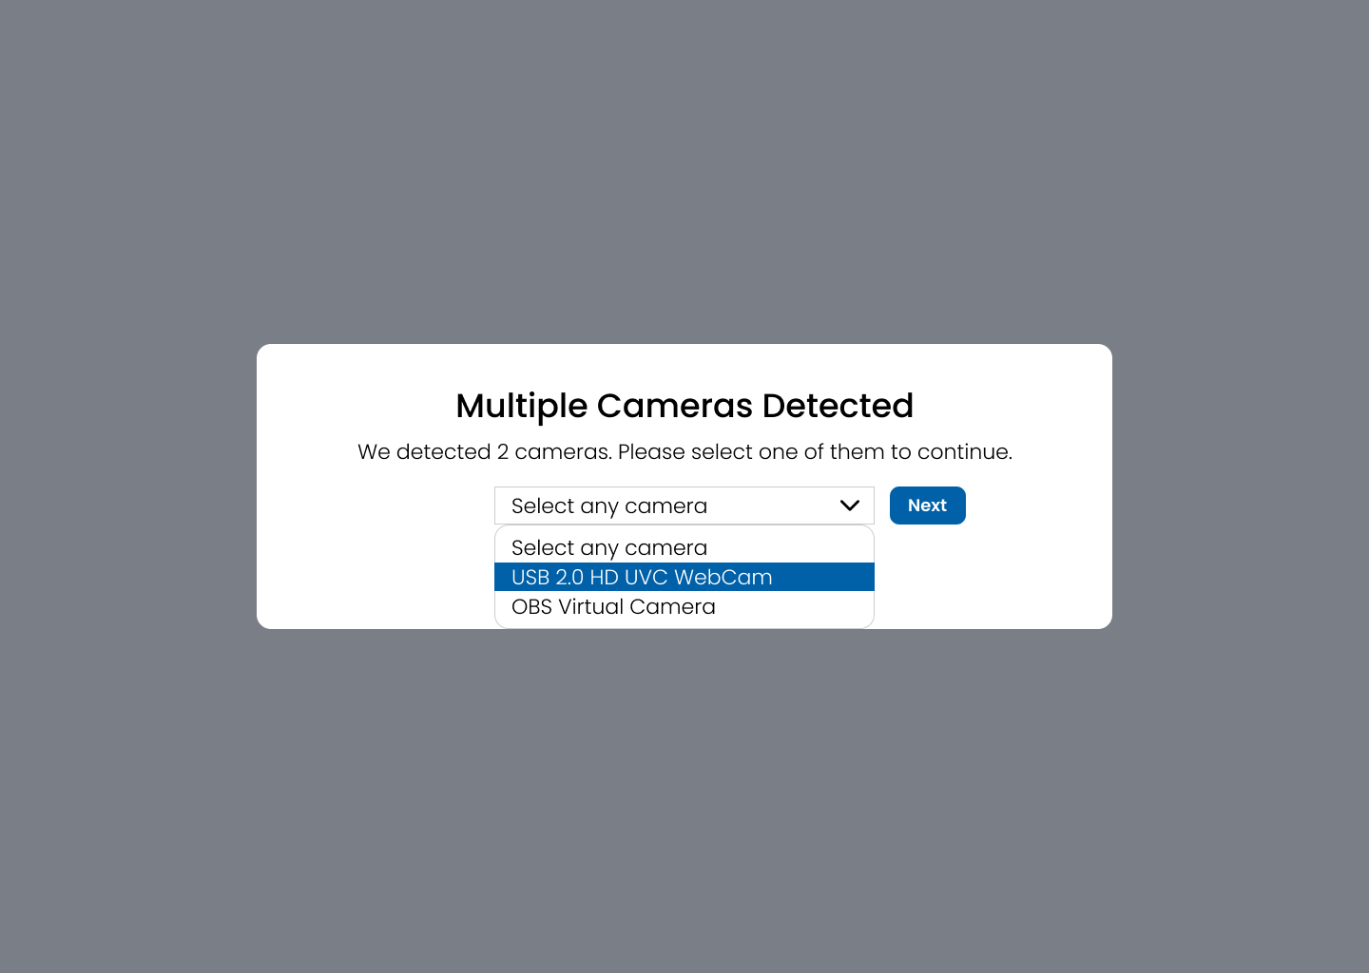

**FIGURE 6: Auto-Proctor - Select Camera**

**FIGURE 6**

This figure is where students select the camera they will use; all detected cameras from their device are available as options.

**FIGURE 7: Auto-Proctor - Selected Camera View**

**FIGURE 7**

This figure displays the captured image or video from the selected camera. It allows the student to check if they selected the right camera and decide whether to proceed or choose a different camera.

**FIGURE 8: Auto-Proctor - Multiple Monitors Detected**

**FIGURE 8**

In this figure, there are multiple monitors detected on the student device. The student has the option of proceeding with multiple monitors, removing the other monitor, or if they think there has been a mistake in monitor detection.

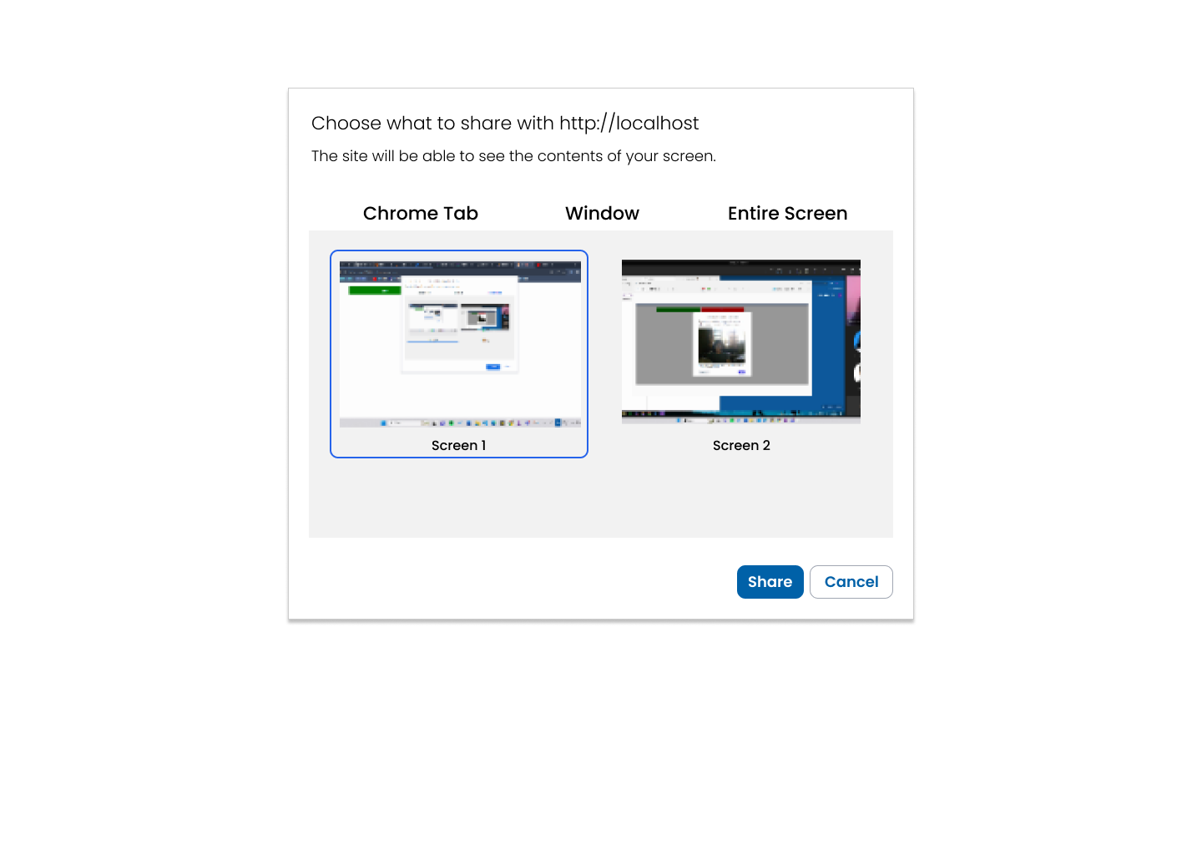

**FIGURE 9: Auto-Proctor - Screen Sharing Options**

**FIGURE 9**

If multiple monitors were detected, in this figure, the student will choose which monitor to be used during the exam. However, during the exam the unfocused screen is still monitored to detect any attempts of cheating.

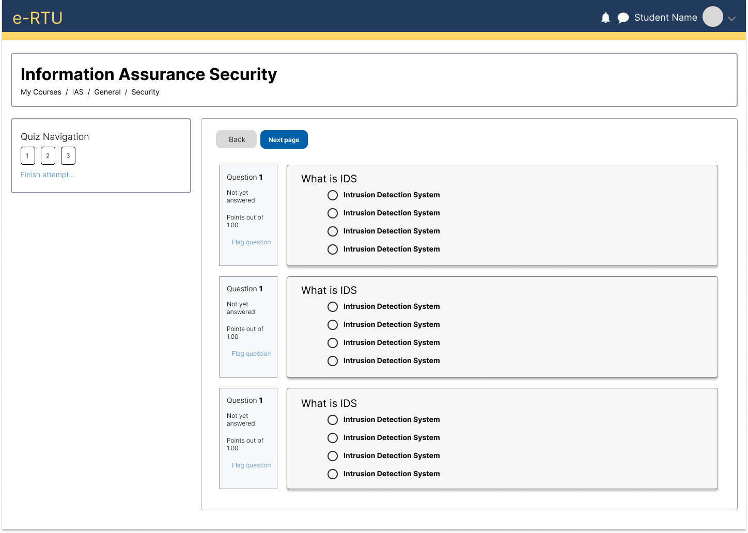

**FIGURE 10: Quiz Taker**

This figure shows the interface for the quiz. Also, featuring a quiz navigation that allows students to effortlessly navigate to different questions.

**WIREFRAME**

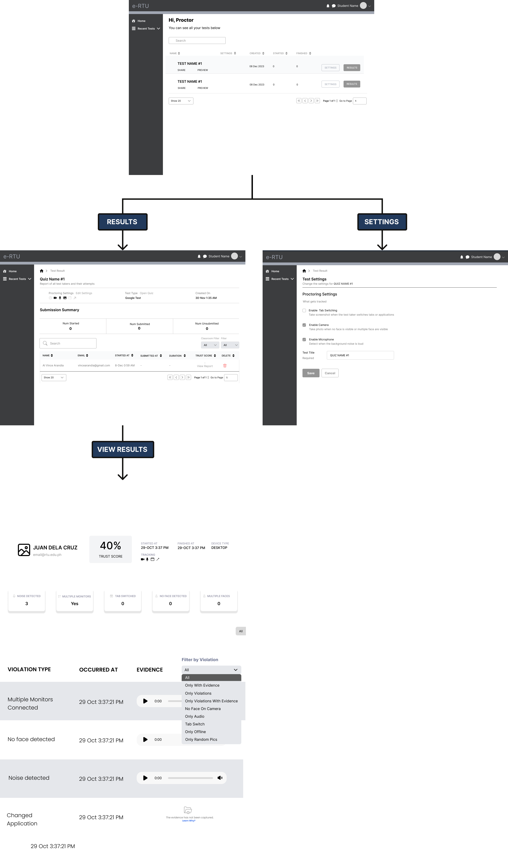

**FIGURE 11: Proctor Module**

**FIGURE 12: Student Module**

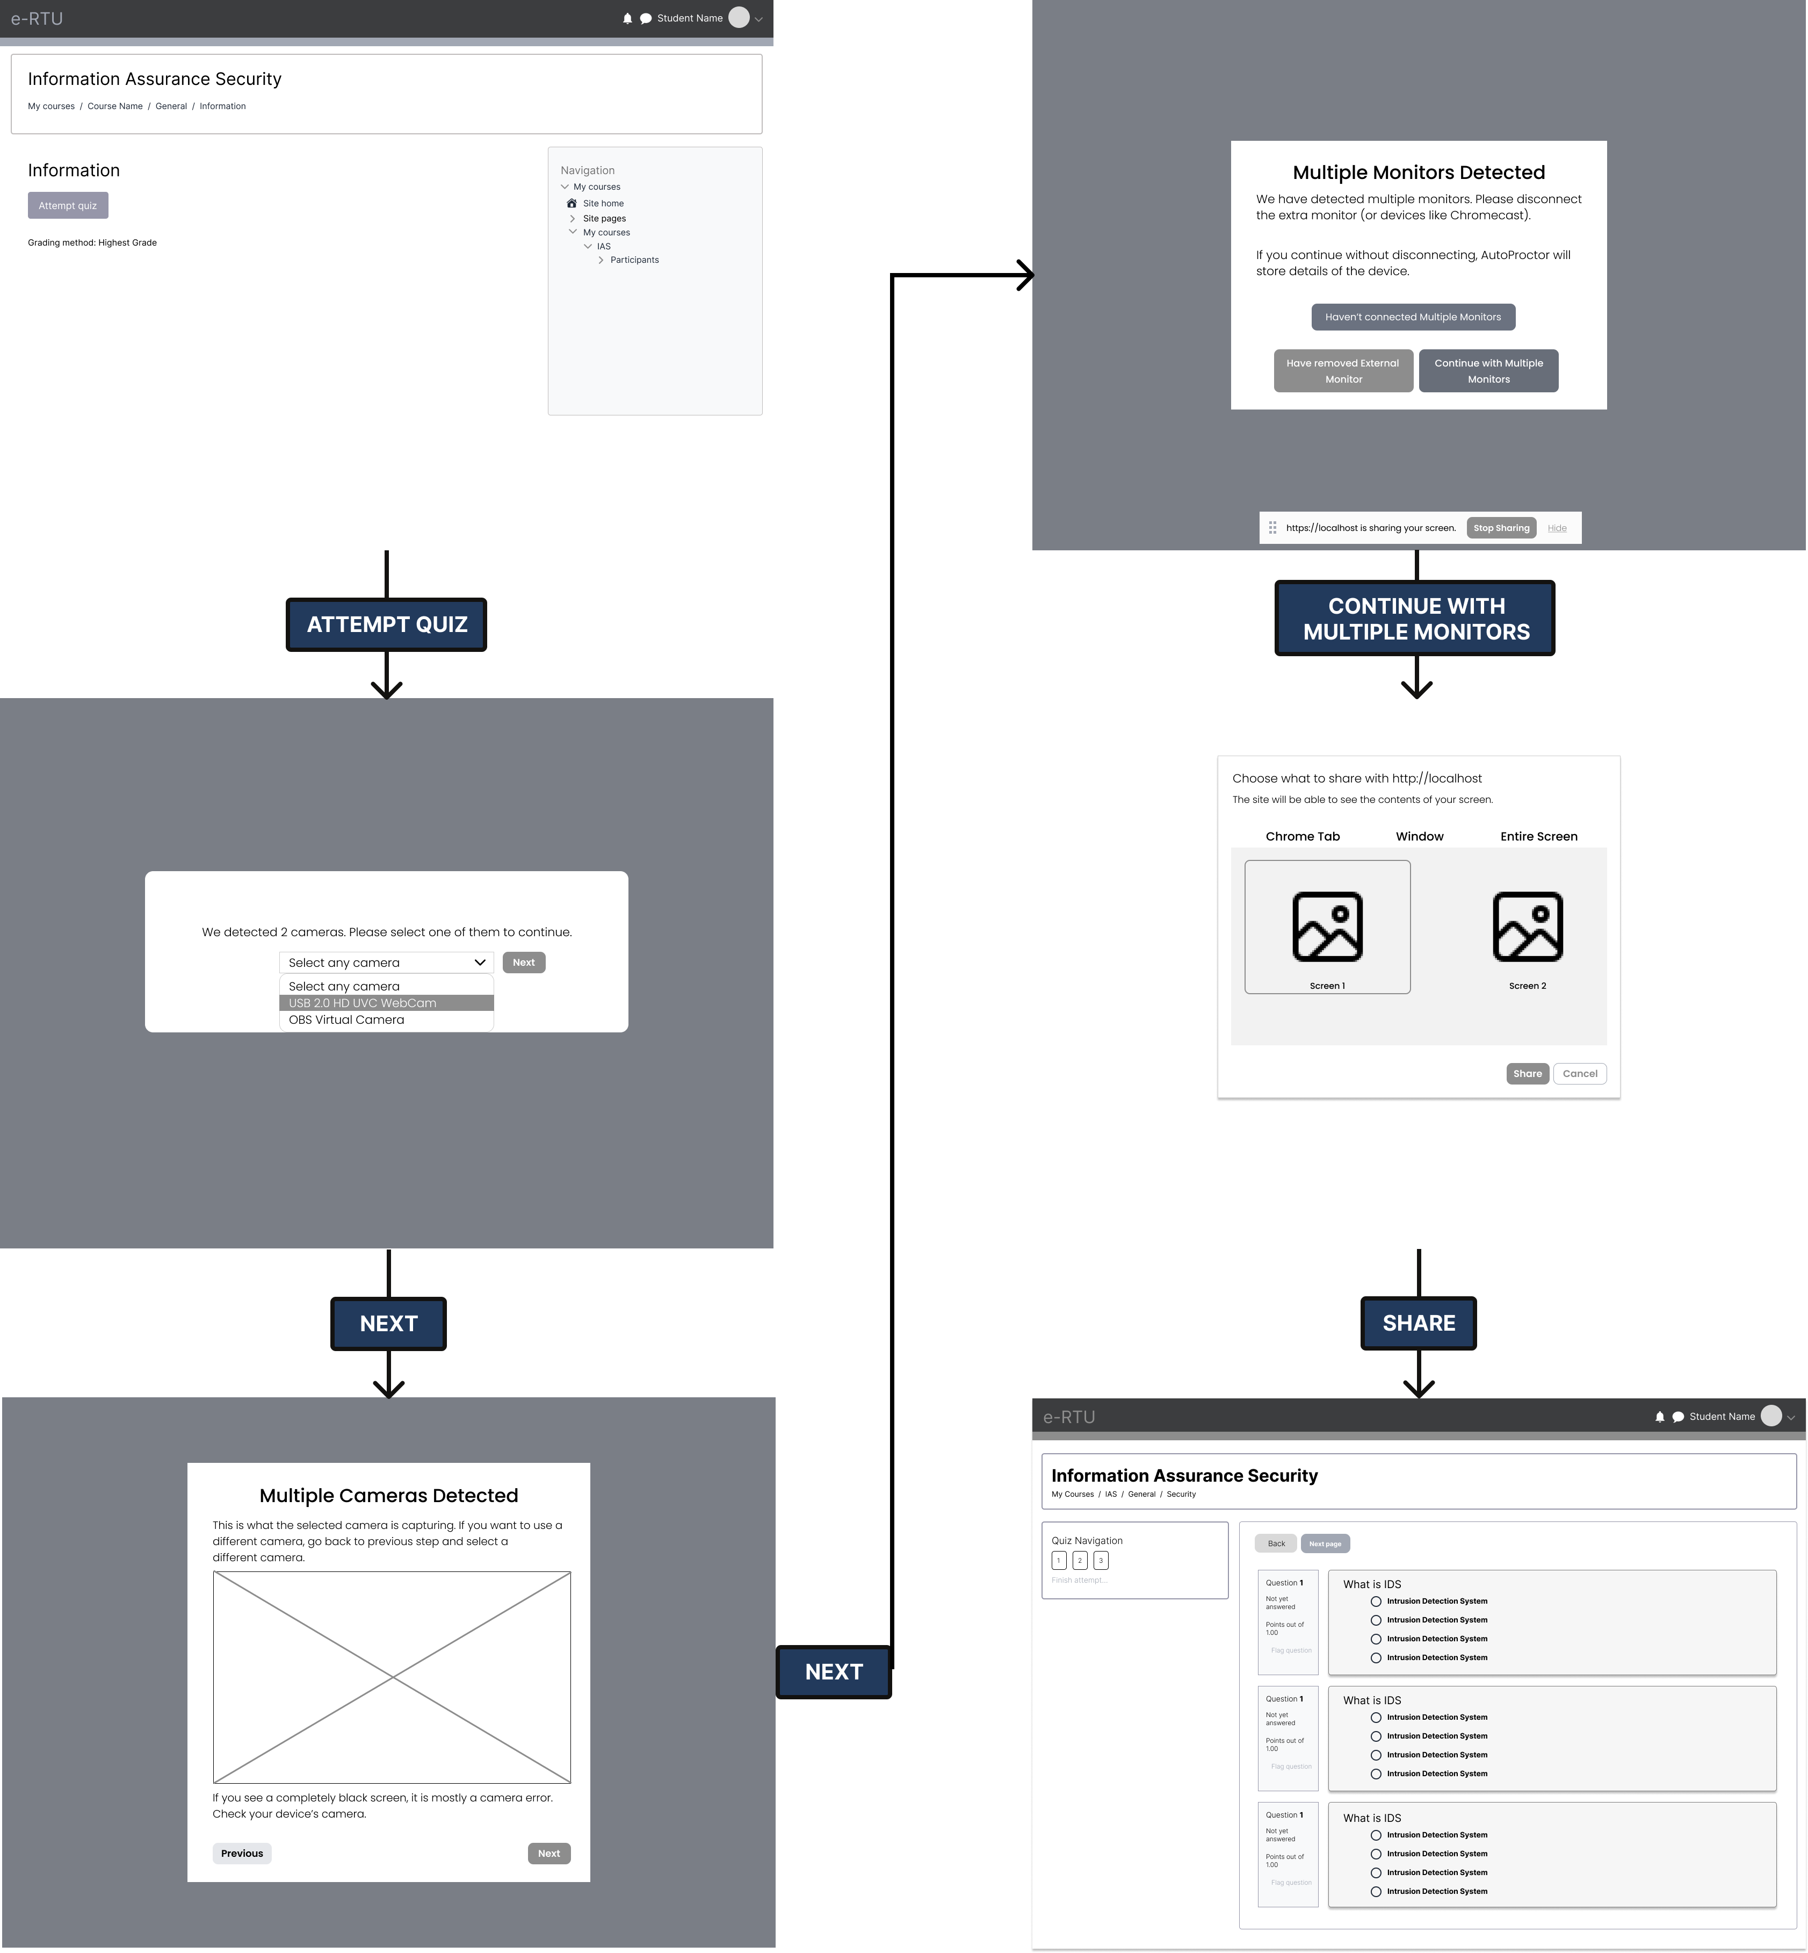

**REFERENCES**

Abdelrahim, Y. (2021). The Effects of COVID-19 Quarantine on Online Exam Cheating: A Test of COVID-19 Theoretical Framework. Journal of Southwest Jiaotong University, 56(2). <https://doi.org/10.35741/issn.0258-2724.56.2.1>

Adnan, M., & Anwar, K. (2020). Online Learning amid the COVID-19 Pandemic: Students' Perspectives. Online Submission, 2(1), 45-51.

Agormedah, Edmond & Henaku, Eugene & Ayite, Desire & ANSAH, Enoch. (2020). Online Learning in Higher Education during COVID-19 Pandemic: A case of Ghana. Journal of Educational Technology and Online Learning. 3. 183-210. 10.31681/jetol.726441.

Al-Maroof, R. S., Alhumaid, K., Alhamad, A. Q., Aburayya, A., & Salloum, S. (2021, May 12). User acceptance of Smart Watch for medical purposes: An empirical study. MDPI. <https://www.mdpi.com/1999-5903/13/5/127>

Amigud, A., Arnedo-Moreno, J., Daradoumis, T., & Guerrero-Roldan, A.-E. (2018). An integrative review of security and integrity strategies in an academic environment: Current understanding and emerging perspectives. Computers & Security, 76, 50–70. <https://doi.org/10.1016/j.cose.2018.02.021>

Arnò, S., Galassi, A., Tommasi, M., Saggino, A., & Vittorini, P. (2021). State-of-the-art of commercial proctoring systems and their use in academic online exams. International Journal of Distance Education Technologies, 19(2). <https://doi.org/10.4018/IJDET.20210401.oa3>

Badve, N., Jagyasi, T., Bansod, S., Dharmik, K., Shekokar, S., Rotke, T., & Gawande, S. (2022, April). Development of Online Exam System for the Institution. IJRASET Journal for Research in Applied Science and Engineering Technology. <https://www.ijraset.com/research-paper/development-of-online-exam-system-for-the-institution>

Barzani, Sami & Jamil, Rayan. (2021). Students’ Perceptions towards Online Education during COVID-19 Pandemic: An Empirical Study. International Journal of Social Sciences & Educational Studies. 8. 10.23918/ijsses.v8i2p28.

Bengtsson, L. (2019, November 6). Take-home exams in Higher Education: A systematic review. MDPI. <https://www.mdpi.com/2227-7102/9/4/267>

Chakraborty, P., Mittal, P., Gupta, M. S., Yadav, S., & Arora, A. (2021). Opinion of students on online education during the COVID‐19 pandemic. Human Behavior and Emerging Technologies, 3(3), 357-365.

Crook, C., & Nixon, E. (2021). How internet Unfortunately, as you didn't specify which paper you are referring to, I'm unable to provide you with a sample of operational definition of terms from it. Could you please provide me with the name of the paper or the context in which it was mentioned so that I can help you better? essay mill websites portray the student experience of higher education. The Internet and Higher Education, 48, 100775.

Elaish, M. M., Shuib, L., Hwang G-J., Ghani, N. A., Yadegaridehkordi, E., & Zainuddin, S. Z. (2021): Mobile English language learning: A systematic review of group size, duration, and assessment methods. Computer Assisted Language Learning. DOI:10.1080/09588221.2021.1931341.

Eren Bilen, Alexander Matros, Online cheating amid COVID-19, Journal of Economic Behavior & Organization, Volume 182, 2021, Pages 196-211, ISSN 0167-2681, <https://doi.org/10.1016/j.jebo.2020.12.004>.

Fitzgerald, A. (2022, December 6). What are plugins?. HubSpot Blog. https://blog.hubspot.com/website/what-are-plugins

Fonseca, J., &amp; Vieira, M. (2014). A Practical Experience on the Impact of Plugins in Web Security. IEEE 33rd International Symposium on Reliable Distributed Systems. <https://ieeexplore.ieee.org/document/6983376/>

Garg, M., & Goel, A. (2022). A systematic literature review on online assessment security: Current challenges and integrity strategies. Computers & Security, 113, 102544.

G N, N., & Nayak, Dr. S. N. (2023). Artificial Intelligence Based Online Examination Proctoring System. International Journal for Research in Applied Science and Engineering Technology, 11(9). <https://doi.org/10.22214/ijraset.2023.54887>

Henge, S. K., Maheswari, G. U., Ramalingam, R., Alshamrani, S. S., Rashid, M., &amp; Murugan, J. (2023, May 21). Dependable and non-dependable multi-authentication access constraints to regulate third-party libraries and plug-ins across platforms. Mendeley. <https://www.mendeley.com/catalogue/9bd3a016-ae3c-30ab-a634-8b52d18c7628/>

Henderson, M., Chung, J., Awdry, R., Mundy, M., Bryant, M., Ashford, C., & Ryan, K. (2022). Factors associated with online examination cheating. Assessment & Evaluation in Higher Education, 1–15.

Janke, S., Rudert, S. C., Petersen, Ä., Fritz, T. M., & Daumiller, M. (2021). Cheating in the wake of COVID-19: How dangerous is ad-hoc online testing for academic integrity?. Computers and Education Open, 2, 100055.

Jowells. (2022, June). Developers: Best practices and guidance regarding plug-in and workflow development for the Microsoft Dataverse - Power Apps. https://learn.microsoft.com/en-us/power-apps/developer/data-platform/best-practices/business-logic/

K. Ahsan, S. Akbar, and B. Kam. Contract cheating in higher education: a systematic literature review and future research agenda. Assessment & Evaluation in Higher Education, pages 1–17, 2021.

Khan MA, Vivek, Nabi MK, Khojah M, Tahir M. Students’ Perception towards E-Learning during COVID-19 Pandemic in India: An Empirical Study. Sustainability. 2021; 13(1):57. https://doi.org/10.3390/su13010057

Kharbat, F.F., Abu Daabes, A.S. E-proctored exams during the COVID-19 pandemic: A close understanding. Educ Inf Technol 26, 6589–6605 (2021). <https://doi.org/10.1007/s10639-021-10458-7>

Lalitha, V.; Periasamy, J.K. Mobile Based Secured Student Online Exam System. Int. J. Eng. Technol. 2018, 7, 118–120.

Lee, Kyungmee & Fanguy, Mik & Bligh, Brett & Lu, Xuefei Sophie. (2021). Adoption of online teaching during the COVID-19 Pandemic: a systematic analysis of changes in university teaching activity. Educational Review. 73. 10.1080/00131911.2021.1978401.

Martin, F., Sun, T., & Westine, C. D. (2020). A systematic review of research on online teaching and learning from 2009 to 2018. Computers & Education, 159, 104009. <https://doi.org/10.1016/j.compedu.2020.104009>

Mesa, O., Vieira, R., Viana, M., Durelli, V. H. S., Cirilo, E., Kalinowsk, M., &amp; Lucena, C. (2018, September). Understanding Vulnerabilities in Plugin-based Web Systems: An Exploratory Study of WordPress. https://www.researchgate.net/publication/326608022_Understanding_Vulnerabilities_in_Plugin-based_Web_Systems_An_Exploratory_Study_of_WordPress

Motwani, S., Nagpal, C., Motwani, M., Nagdev, N., & Yeole, A. (2021, June 15). AI-based proctoring system for online tests. SSRN. <https://papers.ssrn.com/sol3/papers.cfm?abstract_id=3866446#:~:text=Some%20universities%20collected%20assignments%2C%20where,learning%2C%20proctoring%2C%20online%20tests>

Mutawa, A. M., & Sruthi, S. (2022). Students’ perspective towards online proctoring in exams during COVID-19. Journal of Engineering Research (Kuwait), 10(4). <https://doi.org/10.36909/jer.14749>

Muzaffar, Abdul & Tahir, Muhammad & Anwar, Muhammad & Chaudry, Qaiser & Rasheed Mir, Shamaila & Rasheed, Yawar. (2021). A Systematic Review of Online Exams Solutions in E-Learning: Techniques, Tools, and Global Adoption. IEEE Access. PP. 1-1. 10.1109/ACCESS.2021.3060192.Elaish, M. M., Shuib, L., Hwang G-J., Ghani, N. A., Yadegaridehkordi, E., & Zainuddin, S. Z. (2021): Mobile English language learning: A systematic review of group size, duration, and assessment methods. Computer Assisted Language Learning. DOI:10.1080/09588221.2021.1931341.

Njuguna, A. M. (2022, July). User experience of online examinations and proctoring: A case-based study. International Journal of Current Science Research and R. <https://www.researchgate.net/publication/361808864_User_Experience_of_Online_Examinations_and_Proctoring_A_Case_Based_Study>

Noorbehbahani, F., Mohammadi, A., & Aminazadeh, M. (2022). A systematic review of research on cheating in online exams from 2010 to 2021. Education and Information Technologies, 27(6). <https://doi.org/10.1007/s10639-022-10927-7>

Norris, M. (2019). University Online Cheating--How to Mitigate the Damage. Research in Higher Education Journal, 37.

Ozgen, A. C., Öztürk, M. U., Bayraktar, U., & Aksoy, S. (2021). An Anti-Cheating System for Online Interviews and Exams. American Academic Scientific Research Journal for Engineering, Technology, and Sciences, 83(1).

Perante, Wenceslao & Gomba, Felisa. (2021). Challenges to Online Engineering Education during the Covid-19 Pandemic in Eastern Visayas, Philippines. International Journal of Learning, Teaching and Educational Research. 20. 84-96. 10.26803/ijlter.20.3.6.

Rapanta, C., Botturi, L., Goodyear, P. et al. Online University Teaching During and After the Covid-19 Crisis: Refocusing Teacher Presence and Learning Activity. Postdigit Sci Educ 2, 923–945 (2020). https://doi.org/10.1007/s42438-020-00155-y

Sánchez-Prieto, J. C., García-Peñalvo , F. J., Olmos-Migueláñez, S., Chaparro-Peláez, J., & Hernández-García, Á. (2019, January 22). Break the walls! Second-order barriers and the acceptance of Mlearning by first-year pre-service teachers. Computers in Human Behavior. <https://www.sciencedirect.com/science/article/abs/pii/S0747563219300330>

Singh, V., & Thurman, A. (2019). How Many Ways Can We Define Online Learning? A Systematic Literature Review of Definitions of Online Learning (1988-2018). American Journal of Distance Education, 33(4), 289–306. <https://www.tandfonline.com/doi/full/10.1080/08923647.2019.1663082>

Staff, H. (2023, January 20). The perils of plugin-driven web development. HubSpot Developers. https://developers.hubspot.com/blog/the-perils-of-plugin-driven-web-development

Susnjak, T. (2022, December). CHATGPT: The end of online exam integrity?. arXiv Vanity. <https://www.arxiv-vanity.com/papers/2212.09292/>

Ulukol, B. (2022). Online Education and Effects During Covid-19 Pandemic. BRAIN. Broad Research in Artificial Intelligence and Neuroscience, 13(1). <https://doi.org/10.18662/brain/13.1/298>

Ventayen, R. J. M. (2023, February 23). Chatgpt by openai: Students’ viewpoint on cheating using artificial intelligence-based application. SSRN. <https://papers.ssrn.com/sol3/papers.cfm?abstract_id=4361548&amp;download=yes>

Vaswani, A., Shazeer, N., Parmar, N., Uszkoreit, J., Jones, L., Gomez, A. N., Kaiser, Ł., & Polosukhin, I. (2017). Attention is all you need - neurips. Advances in neural information processing systems, pages 5998–6008, 2017. <https://proceedings.neurips.cc/paper_files/paper/2017/file/3f5ee243547dee91fbd053c1c4a845aa-Paper.pdf>

Wen, J., Qin, Y., & Hu, S. (2023, May 23). Abnormal behavior identification of examinees based on improved Yolov5. SPIE Digital Library. <https://www.spiedigitallibrary.org/conference-proceedings-of-spie/12604/2674630/Abnormal-behavior-identification-of-examinees-based-on-improved-YOLOv5/10.1117/12.2674630.short?SSO=1&amp;tab=ArticleLink>

Tweissi, A., Etaiwi, W. A., &amp; Eisawi, D. A. (n.d.). The accuracy of AI-based automatic proctoring in online exams. Electronic Journal of e-Learning. <https://academic-publishing.org/index.php/ejel/article/view/2600>